**Spring Data JPA Tutorial:**

Spring Data JPA will eliminate lots of boiler plate code by following these steps:

1. Create an abstract base repository class that provides CRUD operations for entities
2. Create the concrete repository class that extends abstract base repository class

Spring Data JPA provider is not a JPA provider. It is library/framework that adds an extra layer of abstraction on the top of our JPA provider. If we decide to use spring data jpa then the repository layer of our application contains 3 layers, as follows:

The following figure illustrates the structure of our repository layer:

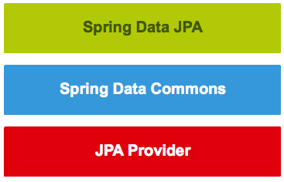

Introduction to Spring Data repositories:

The power of Spring Data JPA lies in the repository abstraction that is provided by the Spring Data Commons project and extended by the datasource specific sub projects.

Following are the interfaces provided by Spring Data Commons project:

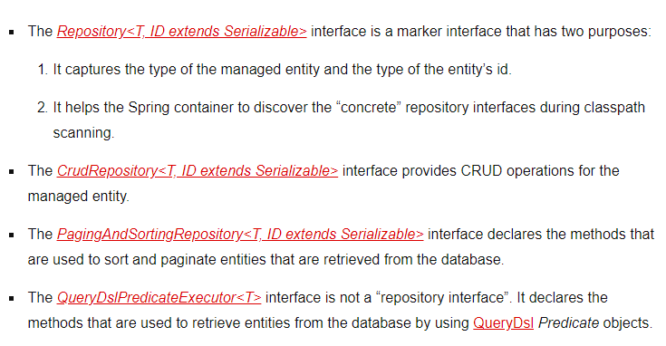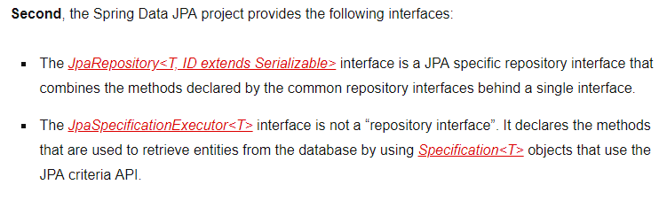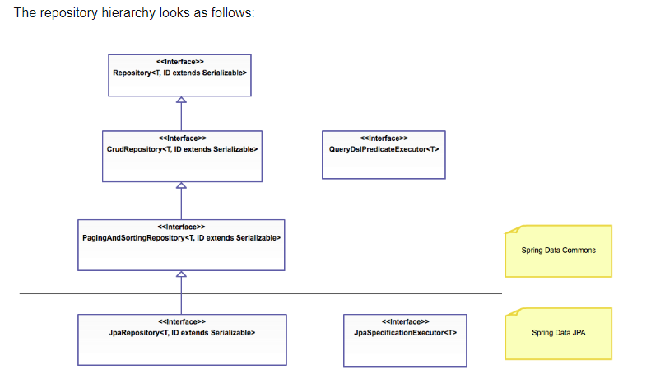

We need to get below components before we start creating Spring Data JPA application,

